**Home Page**

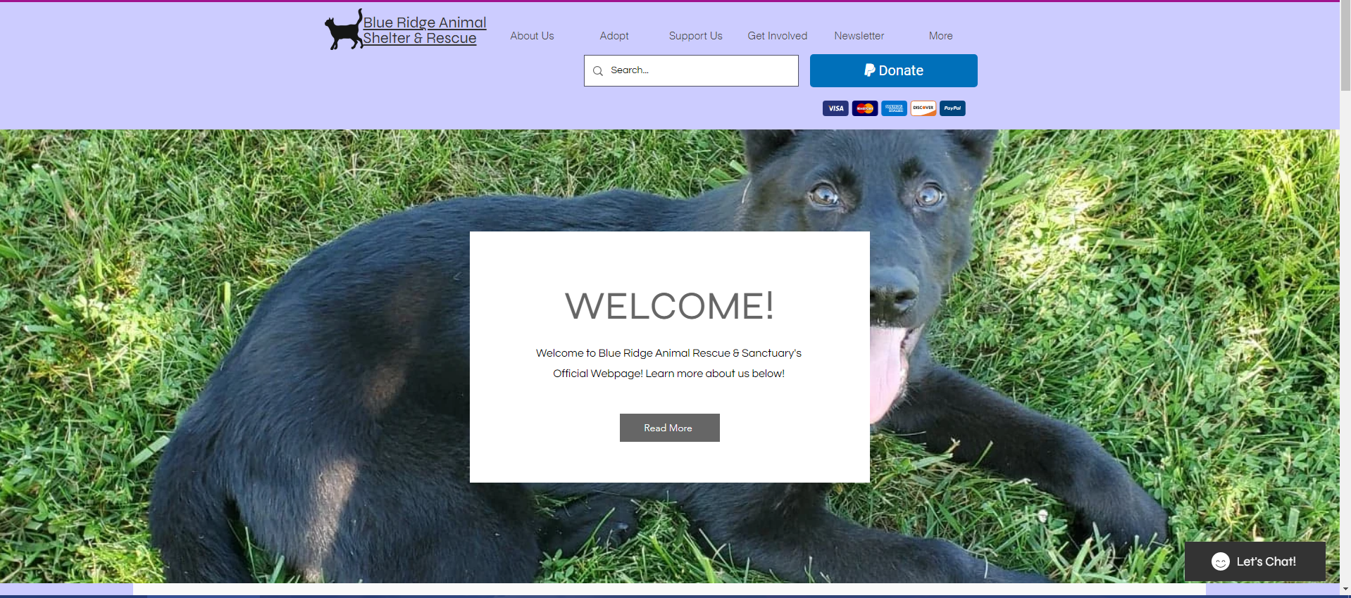

This is the first portion of the “Home” page that users will see upon clicking on Blue Ridge’s Website. This feature of the website welcomes the user and gives them the opportunity to read more in the “About Us” section of the website.

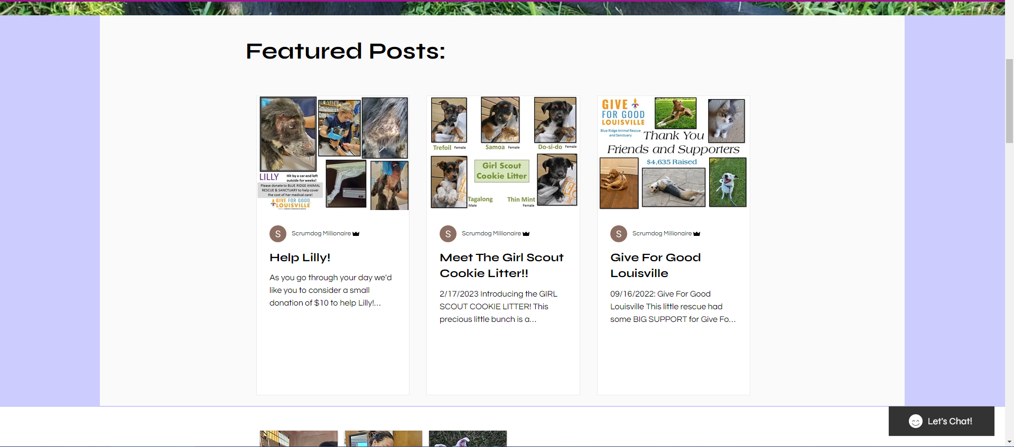

The Home page is almost a summary of everything that is included with this website, and featuring posts from the organization is great for allowing users to learn more about the organization without “attempting” to find the information themselves. Users can click on any of the featured posts and look at information regarding that event/time. Updating this information will be required by the administrator from time to time.

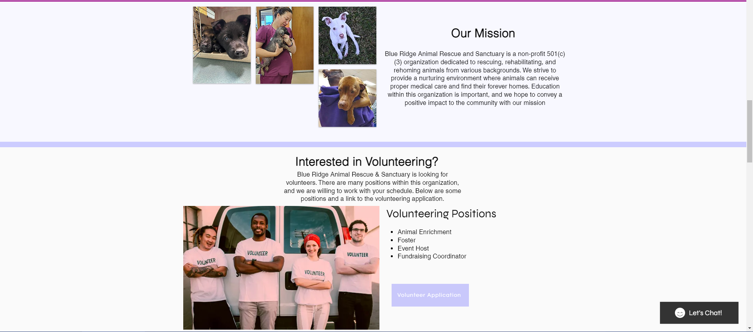

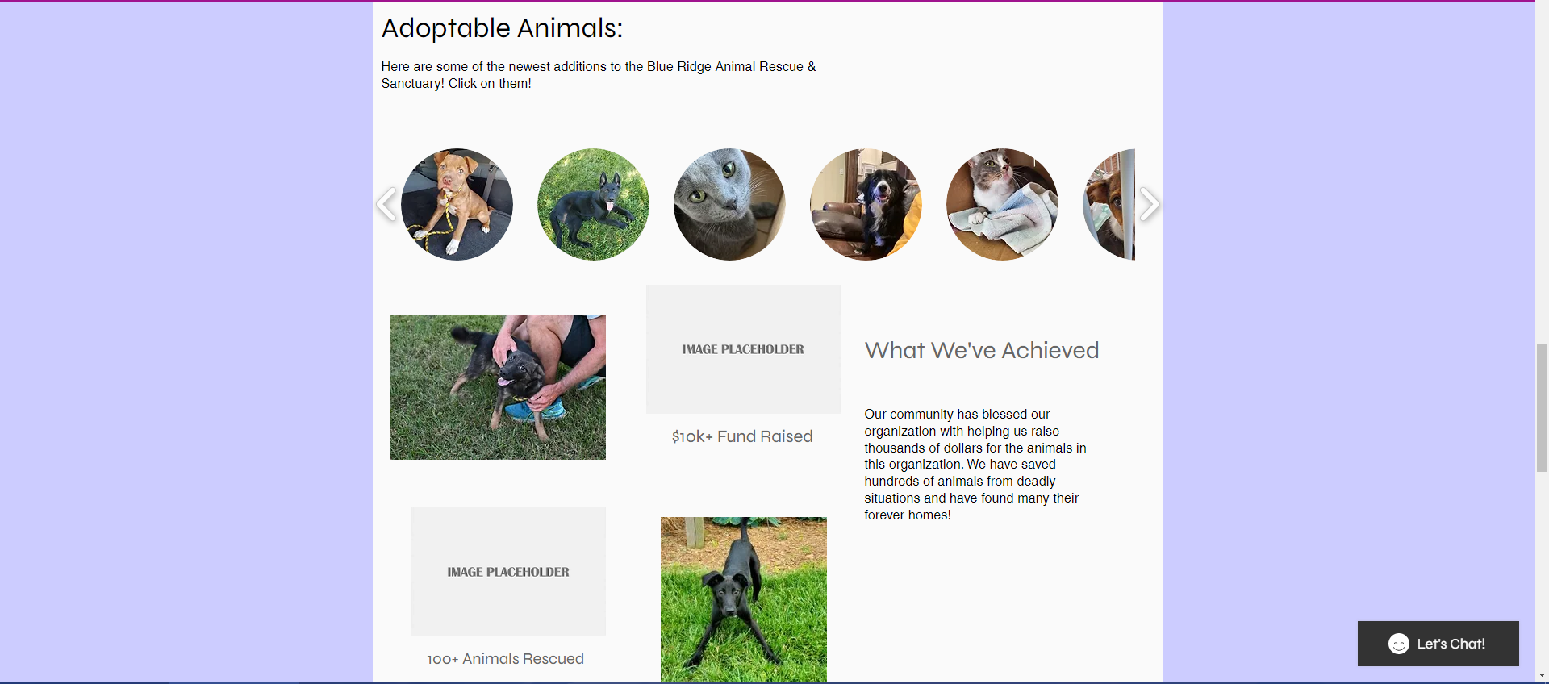

The next two pictures include the organization’s mission statement, a section about volunteering, adoptable animals, and an achievement section with the organization. Since this section of the website is the first thing the user sees, including the mission statement is important. It gives the user a “first” appearance on what defines the organization with an overview of other items on the Home page. Below is a section on adoptable animals. Ideally, these animals will contain a link that will take the user to those animals. As for the achievement section, this section shows that the organization is establishing and meeting goals. This may be important when a user is looking to find some sort of credibility.

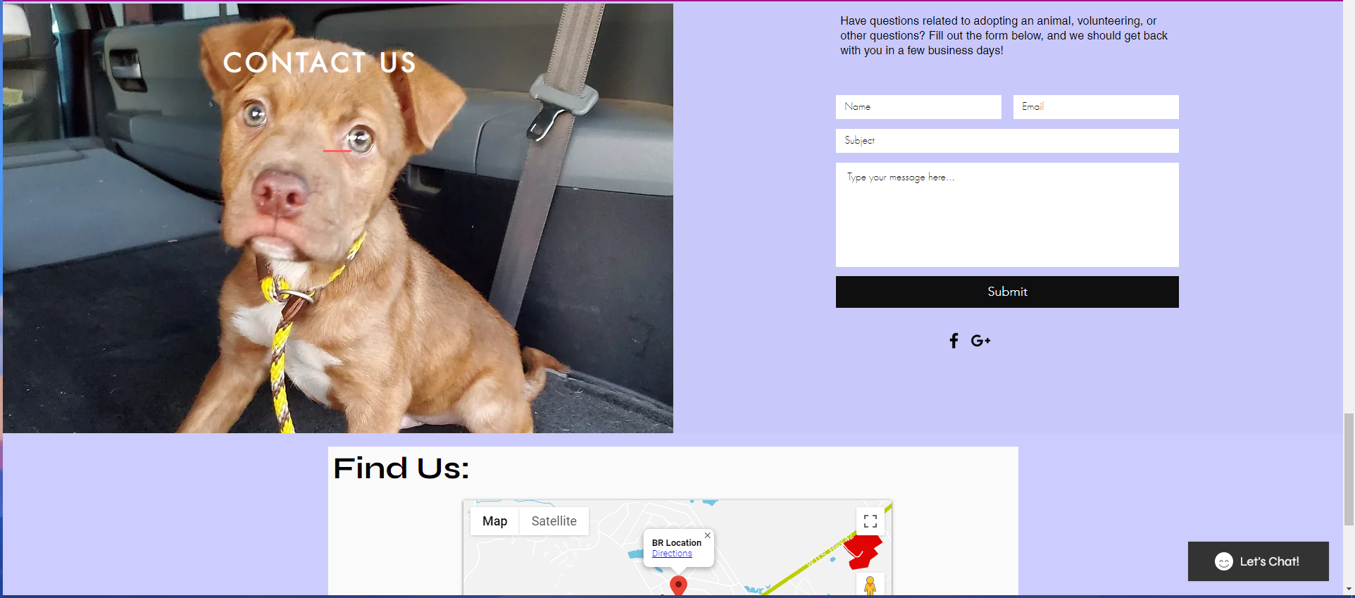

As usual, a contact form in this section might be beneficial for upcoming users. It’s a basic form and it also includes social links below the submission button. A map of the location of the organization can be found below. This seems to be a common thing with websites.

**About Us Page**

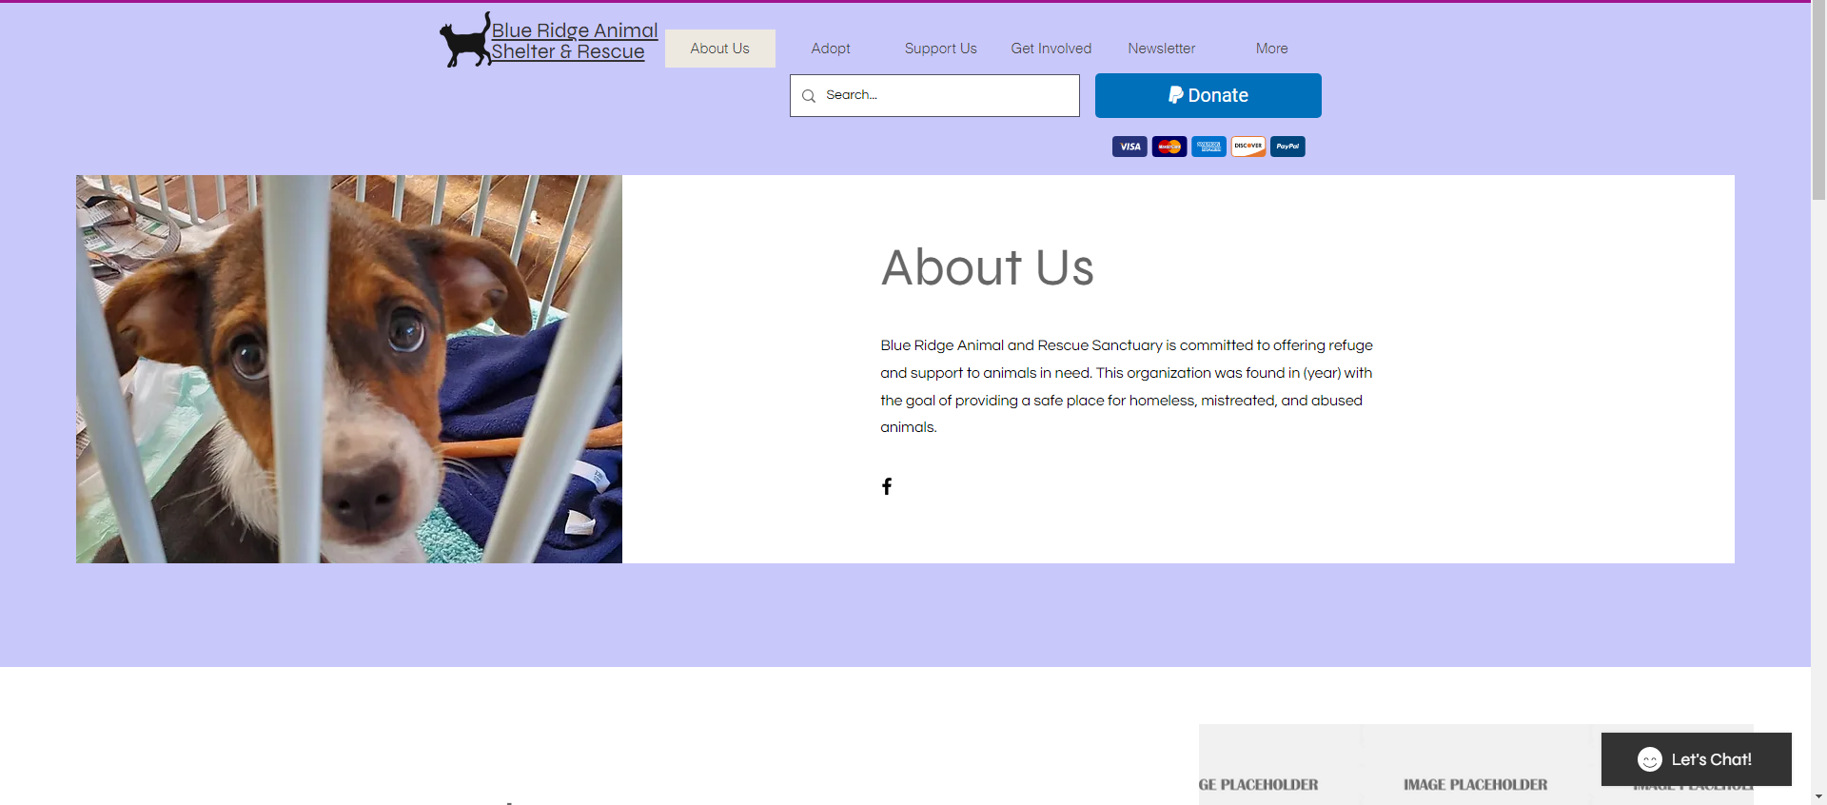

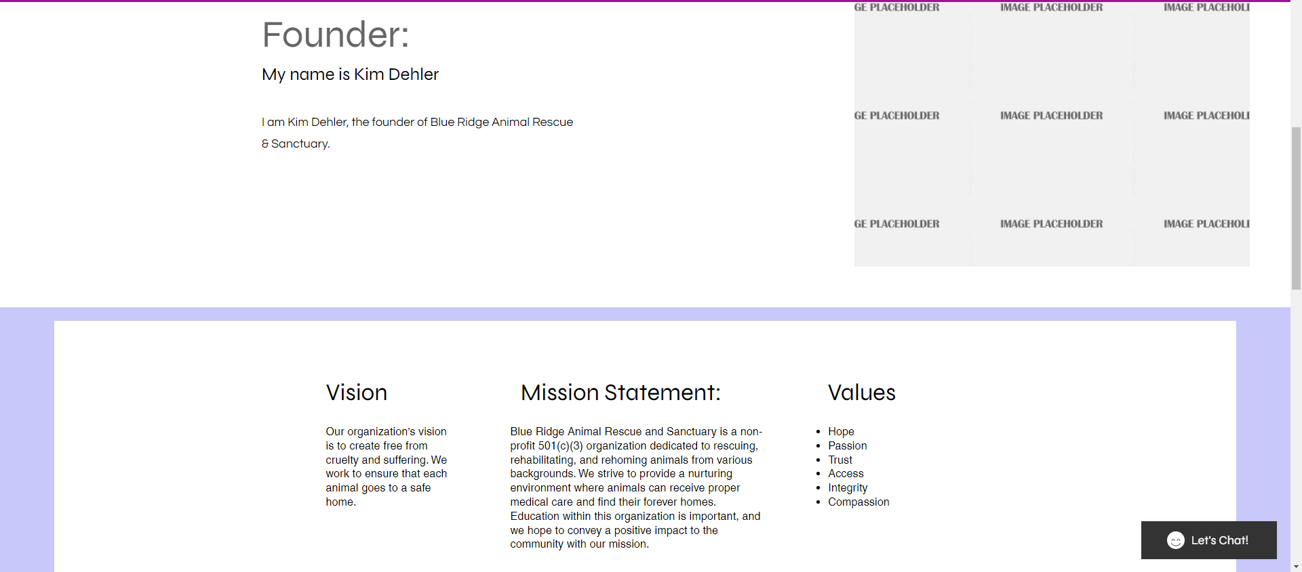

The first two pictures are from the About Us page and display information about the organization and social links to Facebook. A section talking about the founder of the organization and any other staff members may be beneficial to users visiting the website. This section will have a description about the founder along with a picture of the person. From there, users can find the vision of the organization, the mission statement and the values below in a row together.

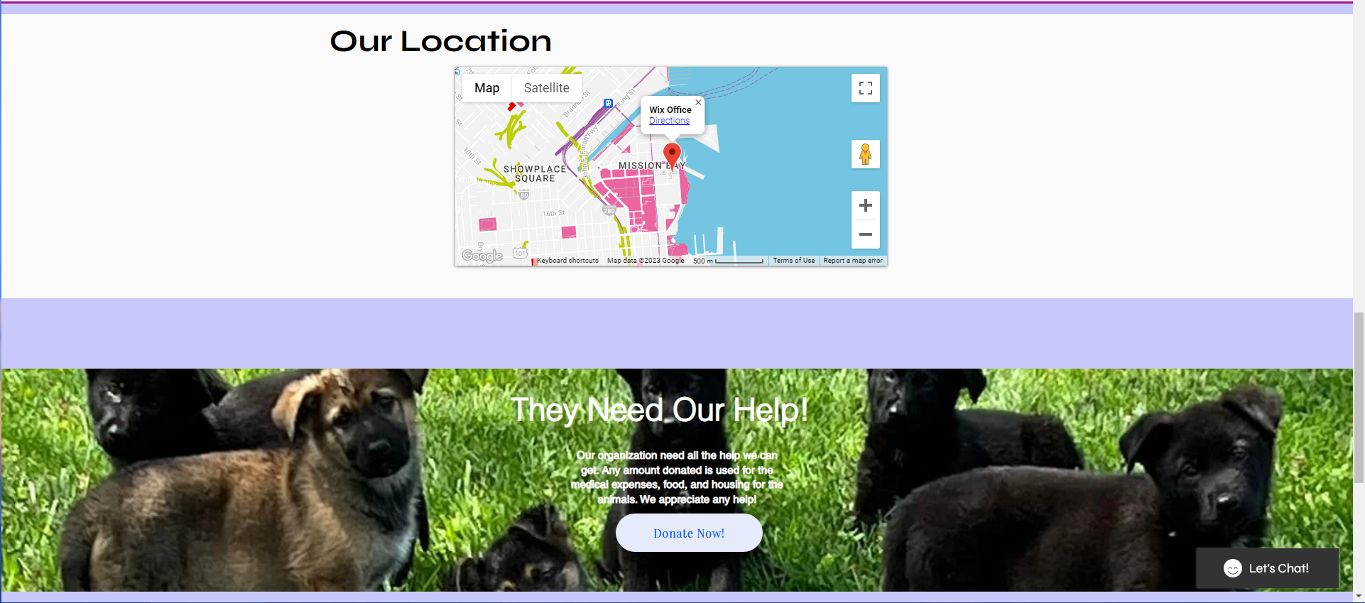

Like the home page, the About Us page will contain a map showing the location of the organization. It may not be needed depending on how the client feels about this, but it is an important aspect. Below is a full-width picture and information box about donating to the organization.

**Adoption Page**

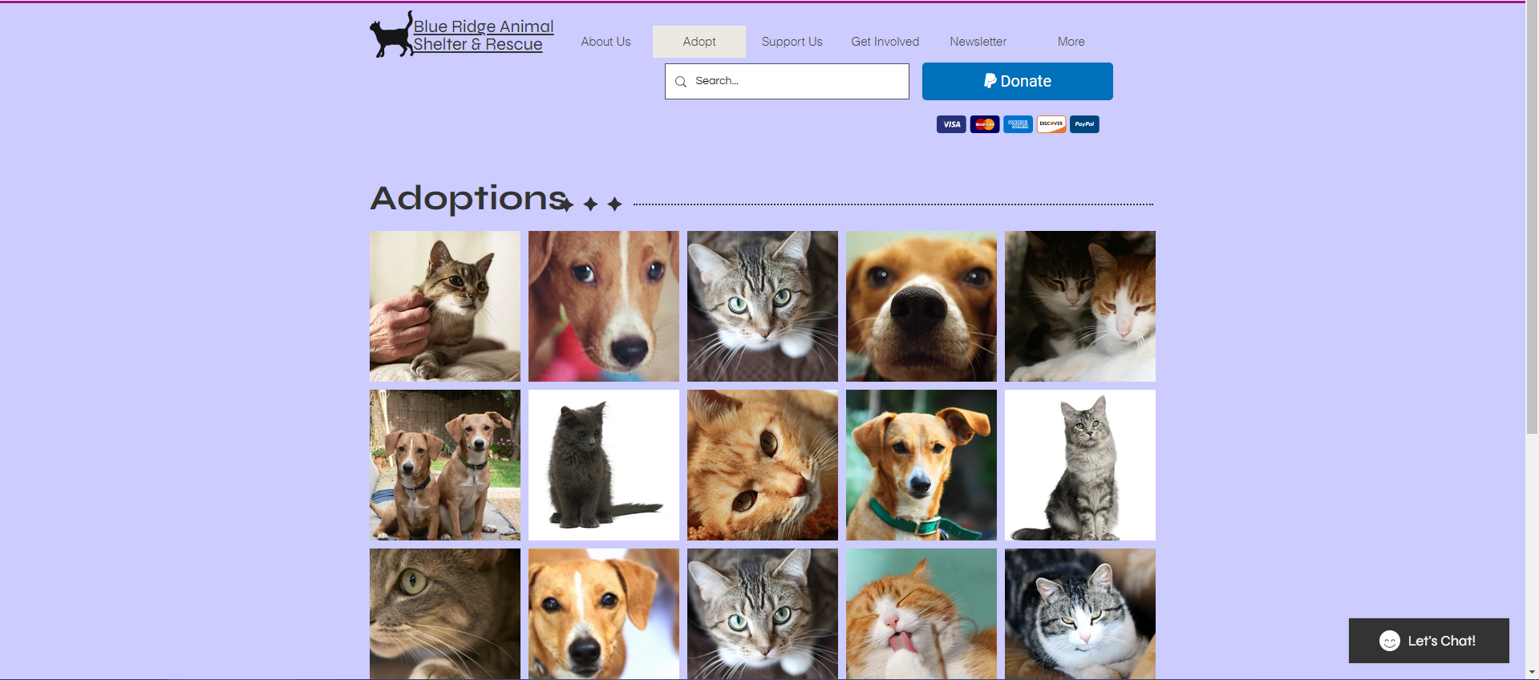

The Adoption Page will list all active animals up for adoption, populated by access to the ShelterLuv database. From this screen, visitors can see information regarding the available animals as well as adoption details, and the application page.

**Support Us Page**

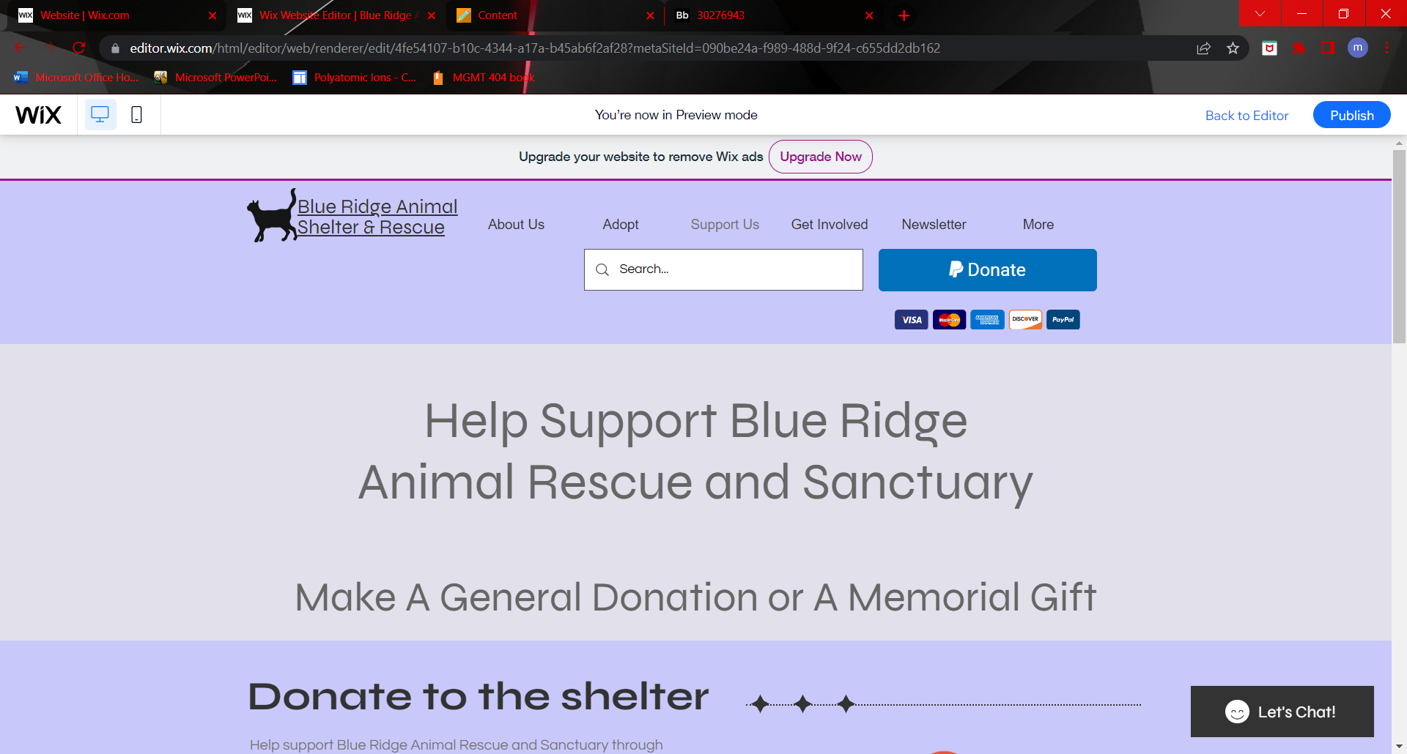

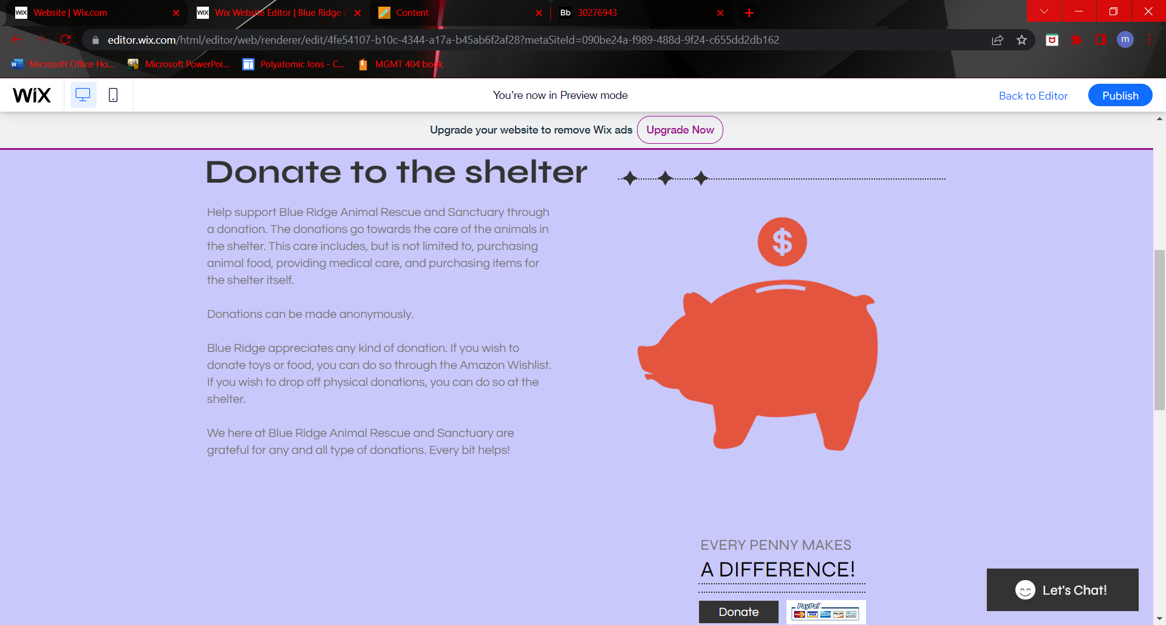

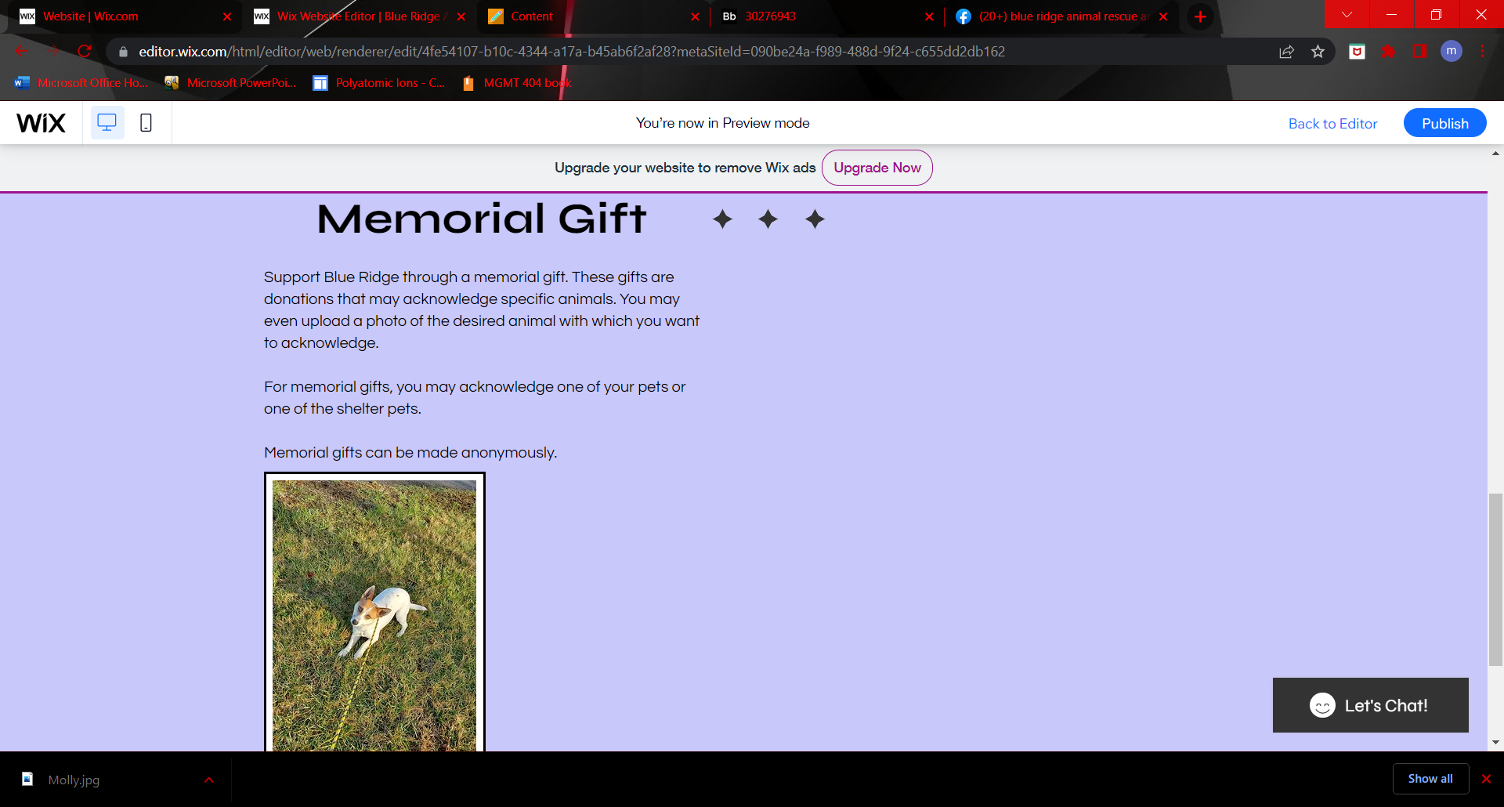

The support us page has the information and links to the donation and memorial gift pages. Here people who are visiting the site can choose one of these options. There is a description about what each kind of donation goes to. We also plan to put a spot on here for an Amazon Wishlist where people can choose to donate specific items, such as toys or food, to the shelter. The actual donation and memorial gift forms are not finished yet. We are waiting for more input about the website to purchase a plan that allows us more features.

**Get Involved / Volunteer Pages**

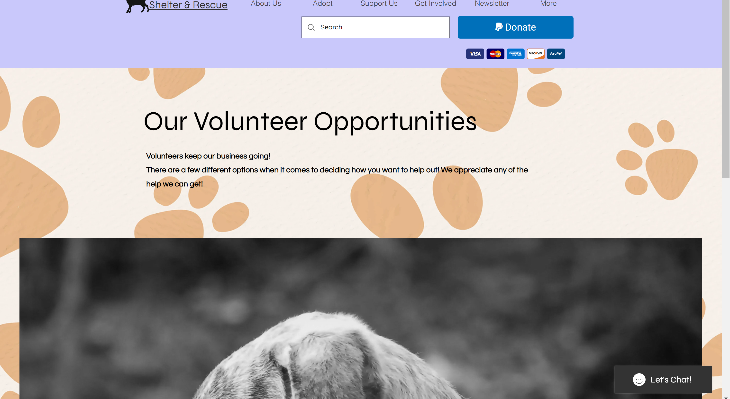

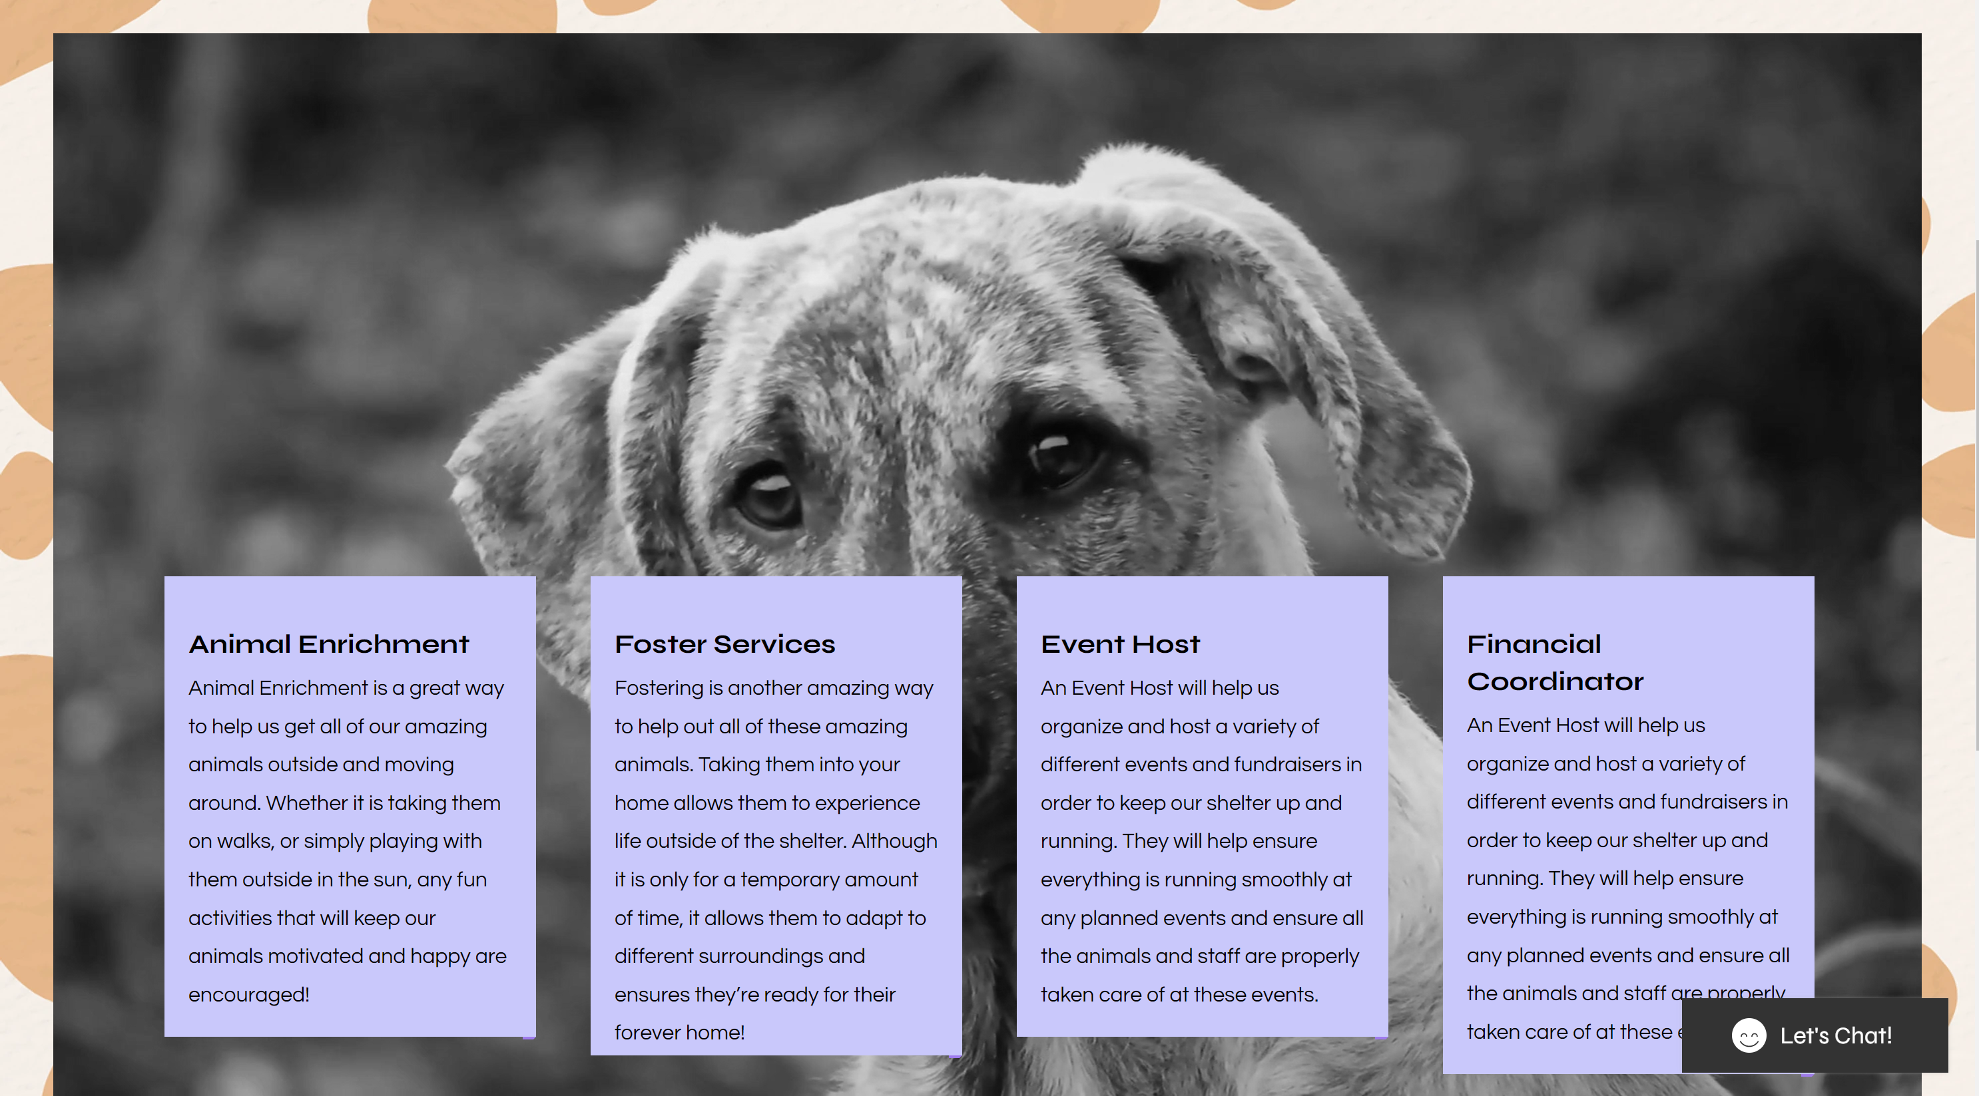

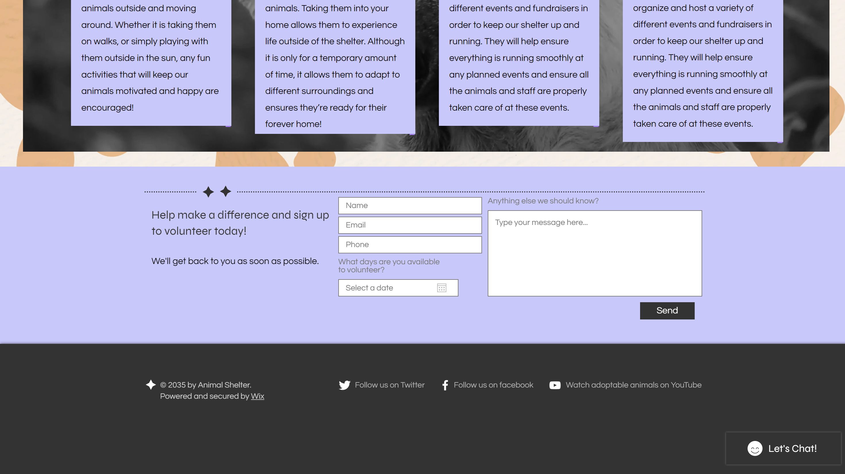

The Volunteer page has a more in-depth description of all our different volunteer opportunities like Animal Enrichment, Fostering, Event Host, and Financial Coordinator. It allows our users to read about what kind of volunteers we’re looking for and provides them with information about the type of work we are doing as well. At the bottom of the page, we have our form for the volunteer application which would be sent directly to Kim allowing her to monitor applications coming in. I decided to stick to the theme of periwinkle and yellow in the background and used a small video to draw in the user's eye.

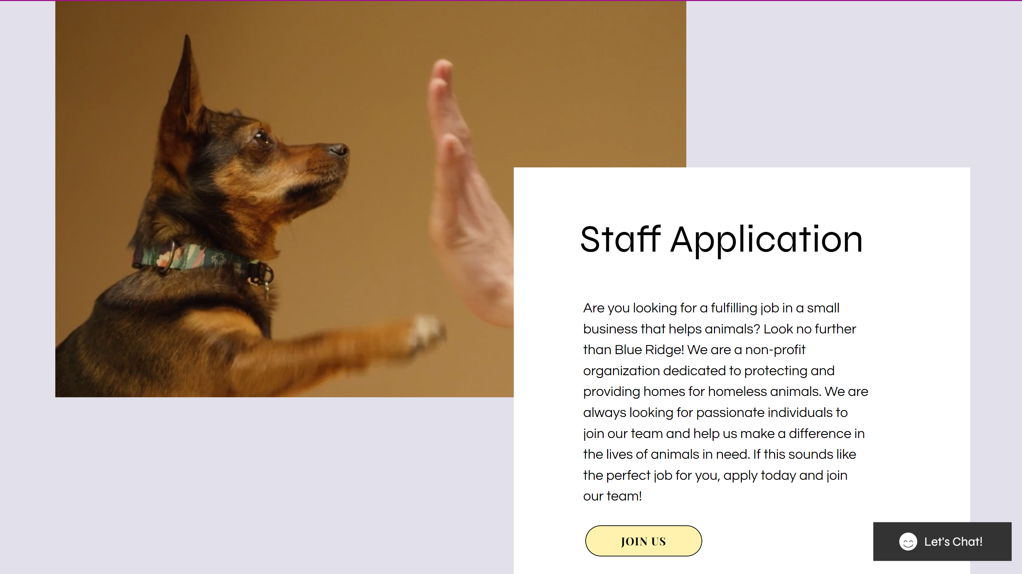

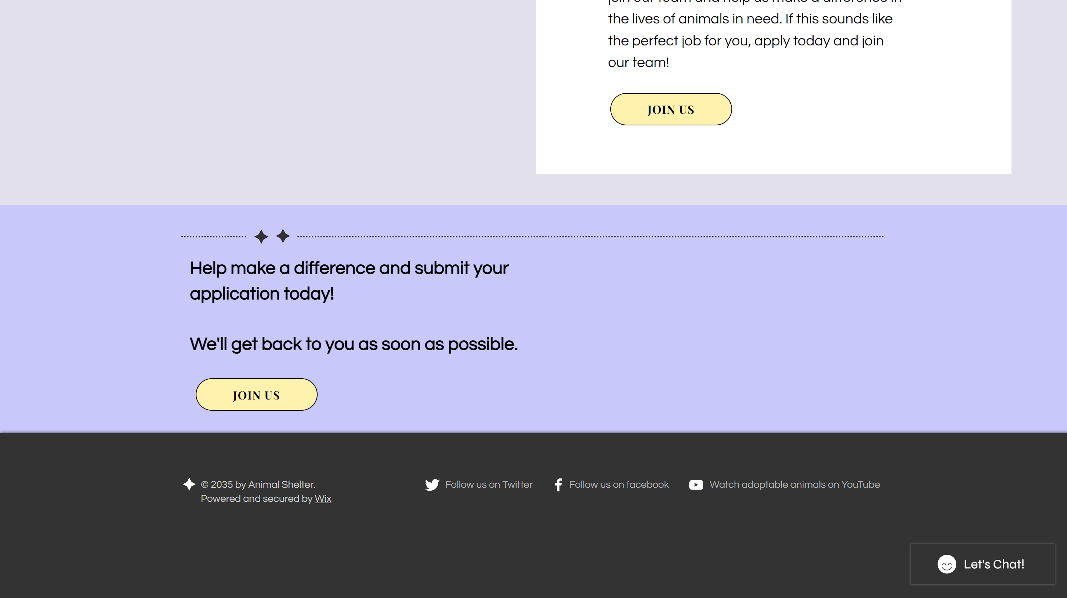

The staff applications page is where we describe the type of staffing we are looking for, while also informing them why Blue Ridge is the right job for them. This of course looks towards the future for Kim once she has enough resources to support permanent staff members other than just herself. We included buttons that would ideally like to have their own form for staffing applications that would differ from the volunteer applications. I also included another fun small video to draw attention to the page and added information next to it making it more likely for the viewer to read it.

**Newsletter Page**

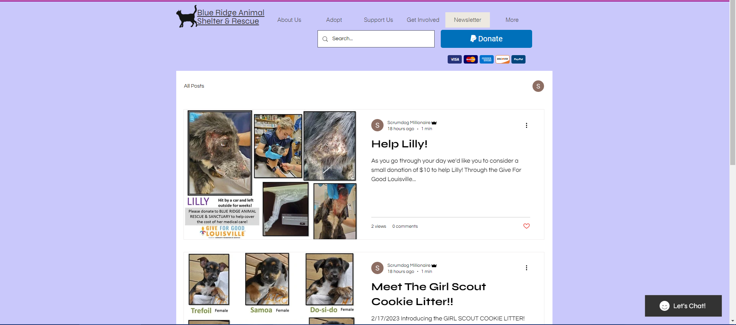

The newsletter page contains updated information released in blog format from the staff to the public, from new adoptions to information for volunteers. Site visitors will also have the ability to sign up for the newsletter and receive a copy of new information to their email.

**Contact Us Page**

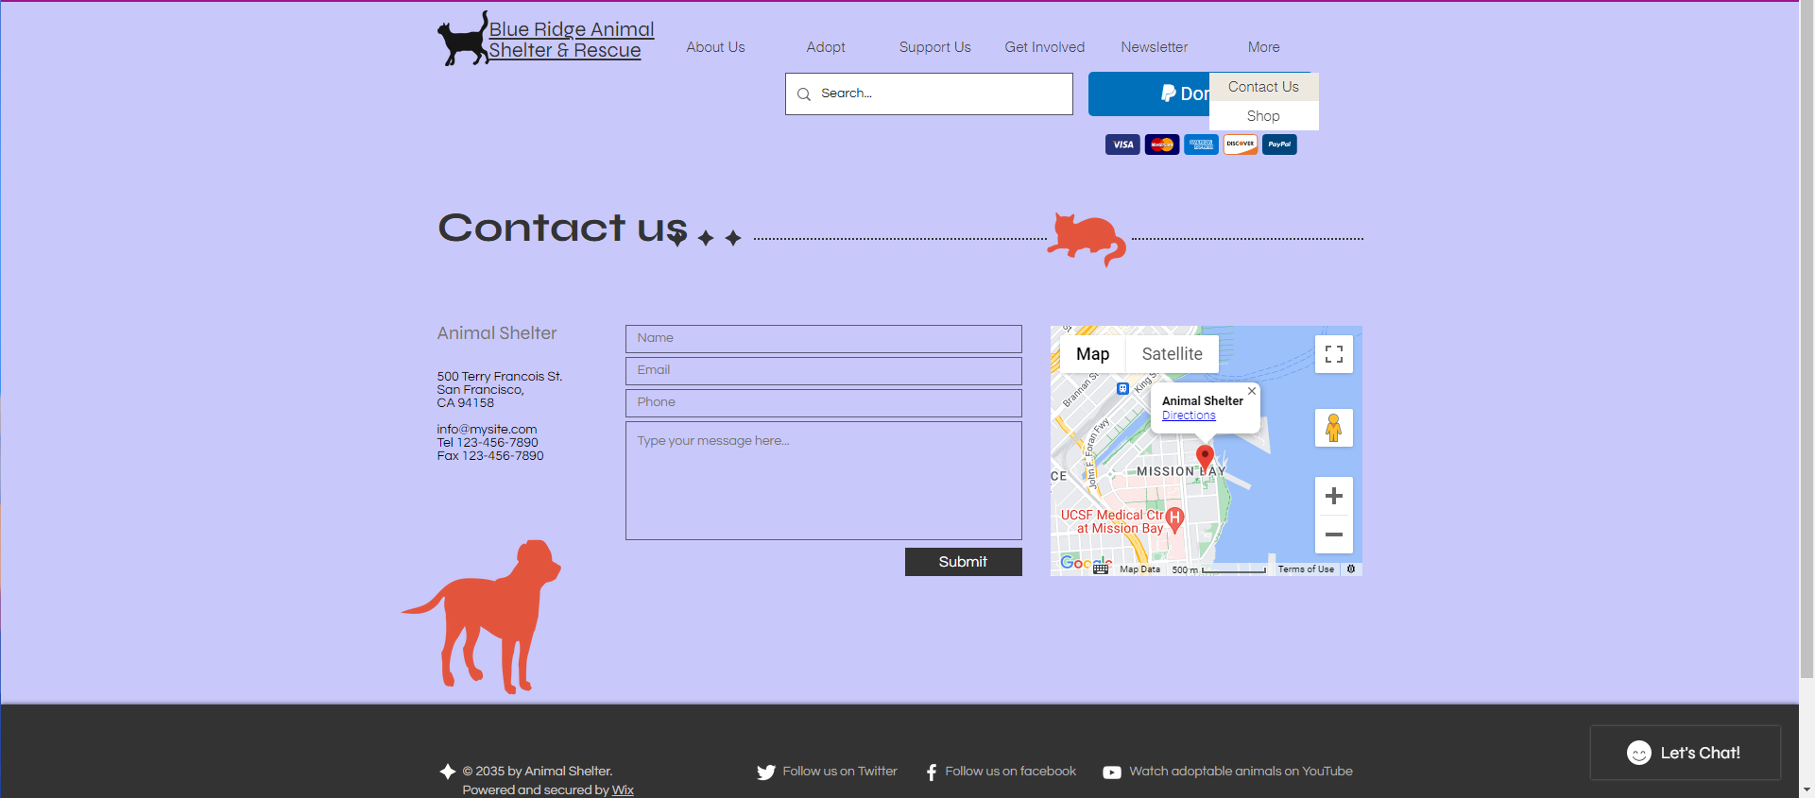

This is the contact form for the organization and contains information such as the address and phone numbers for user reference. It is a basic form and doesn’t require much for a user to submit questions or concerns to the organization.